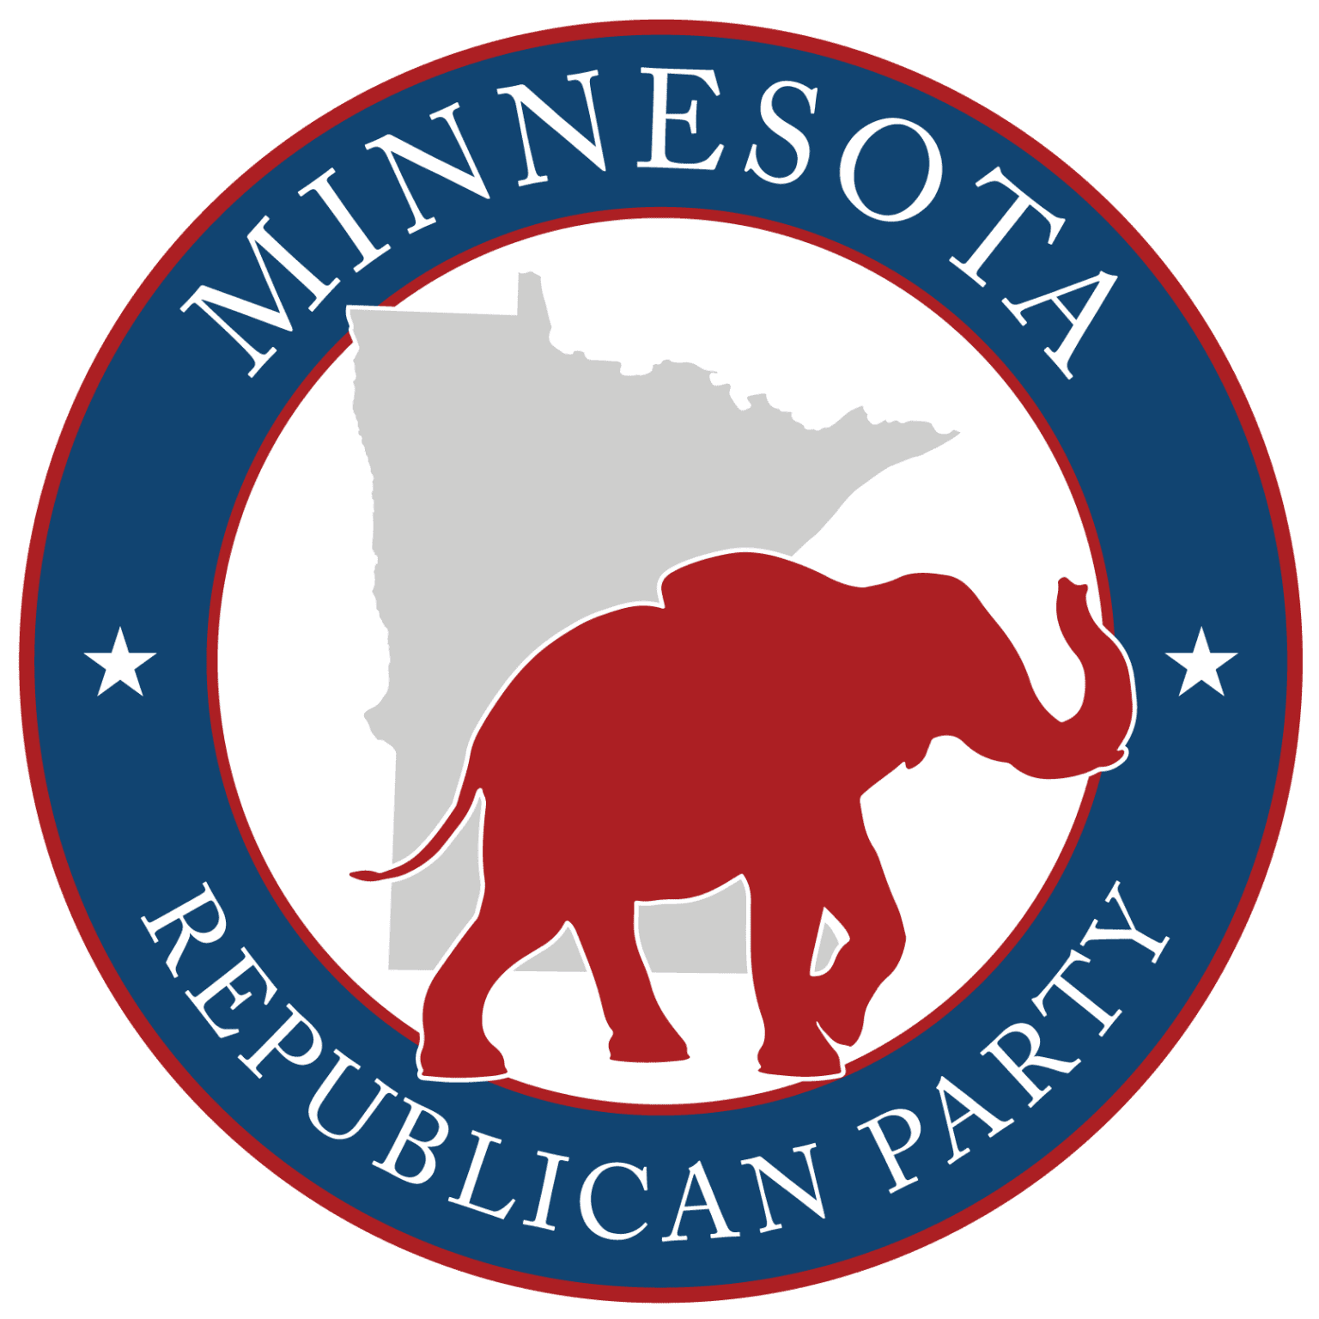

Instructions for Completing the Non-Attendee Participation Form
This form allows eligible individuals who are unable to attend the precinct caucus in person to declare their intent to seek a precinct or BPOU position and to have their submission reviewed in accordance with party rules.
Who May Use This Form
You may complete this form if:
- You are unable to attend the precinct caucus in person, and
- You reside in the precinct listed on the form, and
- You will be eligible to vote in the next General Election, and
- You agree with the principles of the party and intend to support its candidates.

How to Complete the Form
- Complete the Participant Information Section
  - Print your full legal name.
  - Provide your precinct address, city, and ZIP code.
  - Include a phone number and email address where you can be reached.
  - Indicate whether you will be 18 years old by the next General Election.
- Review and Check All Eligibility Statements
  - Read each statement in the Eligibility & Party Agreement section carefully.
  - Check all boxes that apply.
  - Forms missing required eligibility confirmations may be rejected.
- Indicate the Office or Position You Are Seeking
  - Check the appropriate box(es) for:
    - Precinct Officer (Chair, Vice Chair, Secretary, or Other), and/or
    - BPOU Convention Delegate or Alternate.
  - You may select more than one position if permitted under party rules.
- Write Your Candidate Statement
  - Limit your statement to 150 words per office sought.
  - Clearly state your interest, qualifications, and willingness to serve.
  - Write legibly. Illegible statements may not be read to the caucus.
- Sign and Date the Participant Certification
  - Sign and date the form to certify that all information provided is true and correct.
  - Unsigned forms will not be accepted.

Submission Instructions
- Submit the completed form no later than January 27, 2026, using one of the approved methods:
  - Email to the BPOU Chair listed on the form, or
  - Physical drop-off at the location listed.
- Late submissions will not be considered.

Verification Process
- The BPOU Chair will review the form to verify:
  - Timely submission,
  - Eligibility,
  - Compliance with party rules.
  - Legitimacy of individual submitting form for consideration.
- The BPOU Chair’s signature indicates that the submission has been reviewed and verified.
- The BPOU Chair will ensure that absentee submissions are submitted to the proper precinct caucus prior to the start of the caucus.

Important Notes
- Submission of this form does not guarantee election.
- All elections are conducted by those present at the precinct caucus.
- All those in attendance will vote as to whether or not to accept the absentee submission for consideration.
- Questions should be directed to the BPOU Chair or Precinct Secretary listed on the form.

